User Validation Evidence Record
Product: Pawtrace
Purpose of Validation
The purpose of this user validation was to test whether Pawtrace’s key user stories were understandable, useful, and realistic for real users. The validation focused on user experience, task completion, user confusion, quantitative evidence, and whether user feedback could lead to clear design iterations.
The main evidence came from five task-based user tests. Each participant was linked to one core product area: Map View, Data Privacy and Login Trust, GPS Tracking and Electronic Fence, NFC Rescue Card, and AI Photo Check / AI Video Check. After the main functions were improved, we also collected 25 supplementary questionnaire responses to broaden the feedback.
User Testing Process
Each user session followed a similar process:
- Opening and product introduction
We briefly introduced Pawtrace and its main functions, including GPS Tracking, Electronic Fence, NFC Rescue Card, Data & Privacy Agreement, Guest Mode, AI Photo Check, and AI Video Check.
- Initial exploration
Users were asked to explore the product functions once. We recorded the time taken and noted where users felt confused.
- Task-based testing
Each user completed at least one realistic Pawtrace task based on one user story. The tasks covered Map View, Privacy and Login, GPS Tracking, NFC Rescue Card, and AI Health Assistant.
- Observation recording
We recorded task completion, timing, interaction counts, user pauses, confusion points, and whether help was needed.
- Follow-up questions
We asked what was confusing, what users expected to happen, whether they would actually use the feature, and what improvements they wanted.
- Iteration decision
The team used the findings to improve the product design, including moving the place detail card below the map, adding Data & Privacy Agreement and Guest Mode, adding Electronic Fence, removing mandatory login from the NFC rescue process, and adding AI Video Check.
Opening Script
“Thank you for helping us test Pawtrace. We are developing a smart pet-care prototype that combines GPS Tracking, Electronic Fence, NFC Rescue Card, privacy protection, and AI-supported health functions. We are testing our design, not you, so please tell us honestly what you find clear, confusing, useful, or unnecessary.”
—————————————————————————————————————————————————-----------------------
—————————————————————————————————————————————————-----------------------
User 1 —
Map View and Place Detail Card
User Story
As a pet owner, I want to view my pet’s location and nearby pet-friendly places on the same map screen, so that I can understand where my pet is and where useful places are without losing map context.
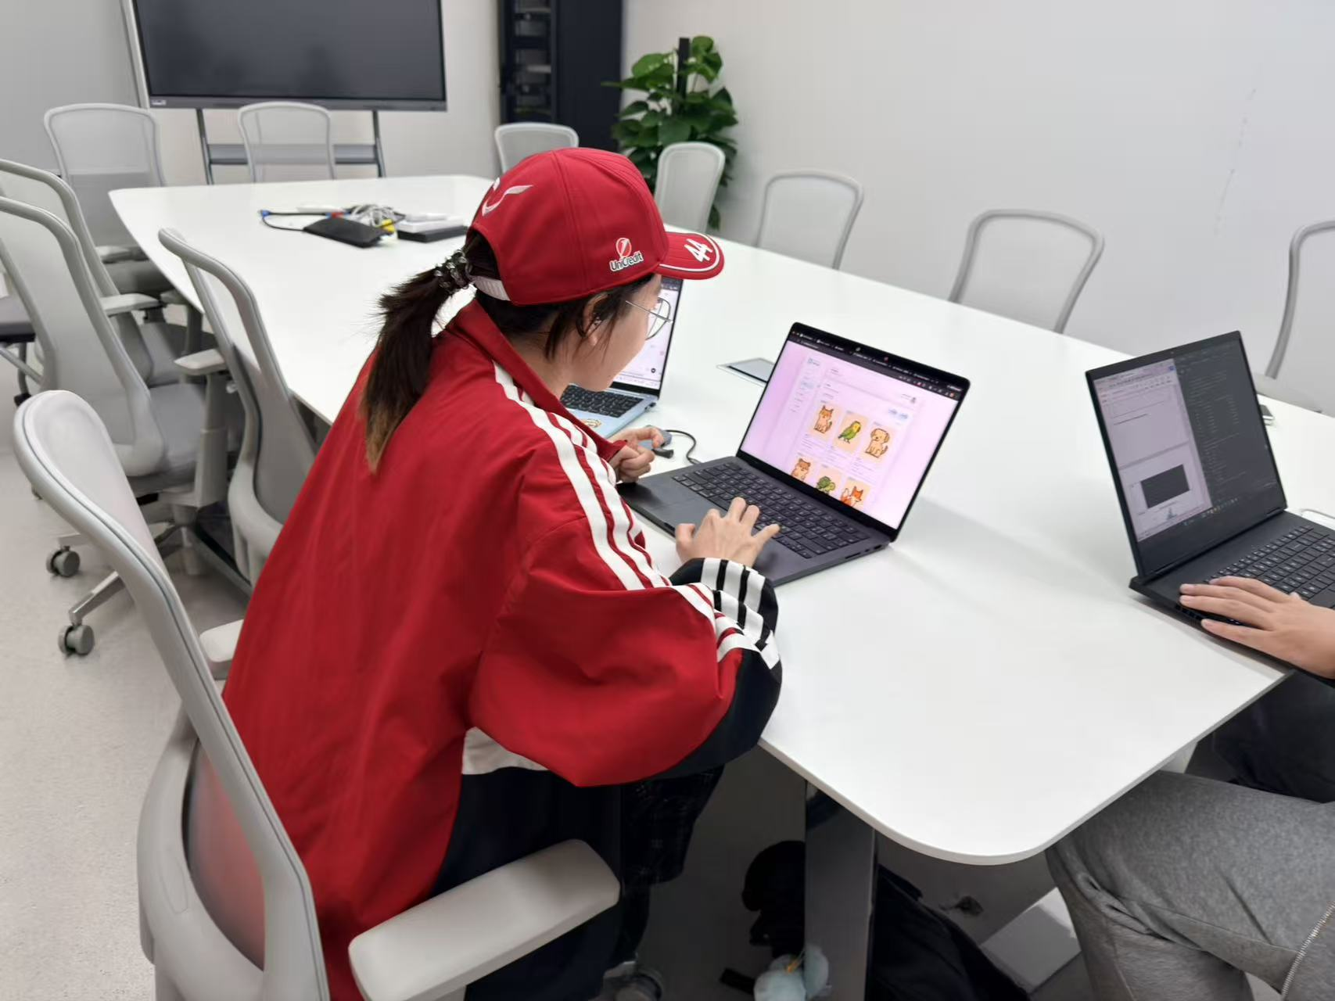
User Activity
·The user was asked to carefully explore the Map page.
·The user was asked to find the pet’s location on the map.
·The user was asked to open a nearby place detail card within the required 20 seconds.
·The user was asked to explain the actual real-world location shown in the place card.
·The user was asked to rate the interface layout and visual clarity on a 5-point scale.
User Validation Criteria
Metric | Target / Standard
Detail finding time | User can find the place detail card within 20 seconds.
Map context visibility | User can view the map and place detail information without losing location context.
Error evidence | If the user tries to move or zoom the map repeatedly, or says the map is blocked, this counts as a usability issue.
Visual clarity rating | User gives the map clarity a score of at least 4 out of 5 after optimisation.

User Feedback
User 1 spent around 5 minutes exploring all related functions and could open the place detail card, but the card appeared as a pop-up over the map. The user paused and tried to move or zoom the map because the card covered part of the location information. This showed that the design made it difficult to view the map and the place details at the same time.
Quantitative evidence before optimization:
- Map obstruction count: 1 major obstruction
- Detail finding time: 20 seconds
- Extra scroll count: 3–4 times
- Map clarity rating: 2/5
Iteration Result
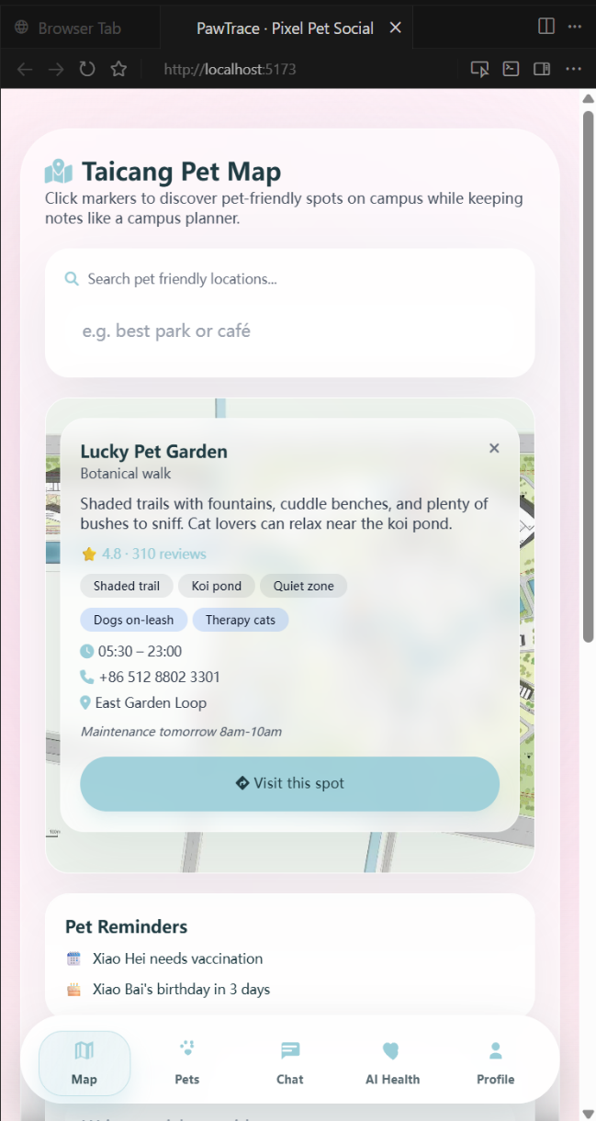
Key iteration: The place detail card was moved from a map pop-up to a fixed area below the map.
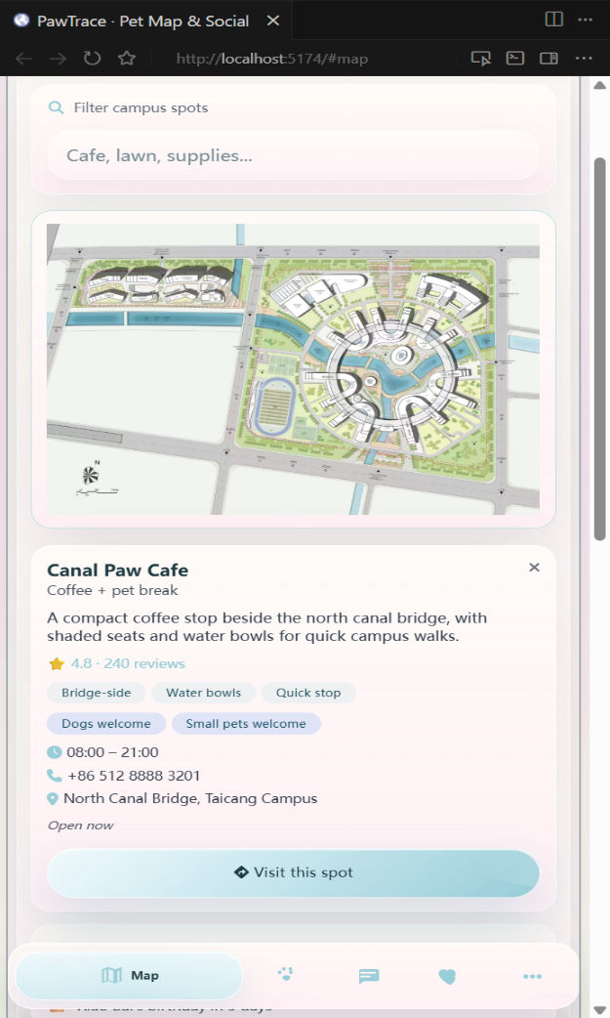
After optimization, the user could view the map and detail information at the same time. The location relationship became clearer, and the user could find the detail information faster.
Quantitative evidence after optimization:
- Map obstruction count: 0
- Detail finding time: 2 seconds
- Extra scroll count: 0–1 time
- Map clarity rating: 4.5/5
This iteration shows that the map interface was improved based on user observation and measurable evidence.

